PUBLIC OUTREACH EVENT!
THURSDAY, JANUARY 26, 2023
GLORYA JEAN TATE PARK UPGRADES
2:00 to 5:00 PM at 2866 Second Ave, Marina CA
(in the event of rain, please go to 211 Hillcrest Ave, Marina CA)
6:00 PM at City Council Chambers
211 Hillcrest Ave, Marina CA

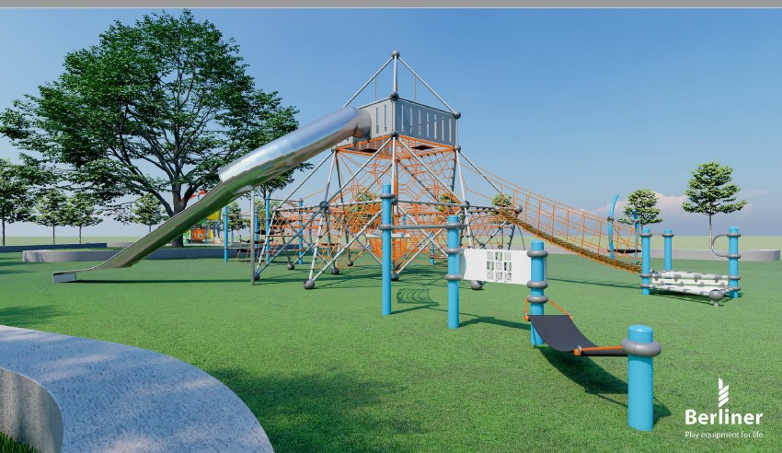
Glorya Jean Tate Park is being upgraded. The City of Marina is holding a meeting to gather public input on the next phase of improvements at the park located near Reservation Road and Cardoza Avenue.
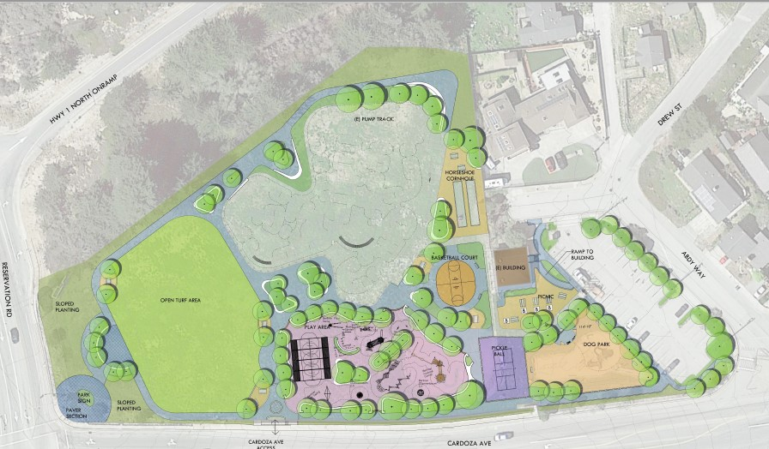

Please join this Public Meeting so that Your Voice can be heard.
Bring your Questions, Comments, and Advice.

Any further questions, comments or if you are unable to attend please use email: ourparksgjt@cityofmarina.org

