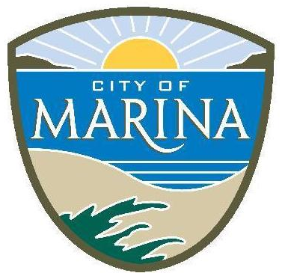 | CITY OF MARINA ODOR ATTRIBUTION STUDY
 | WE ARE LOOKING FOR VOLUNTEERS TO PARTICIPATE IN AN ODOR INVESTIGATION PANEL

DESCRIPTION OF PROJECT:
An odor panel of 40 volunteers is needed to assist in smelling and evaluating odor samples. There have been a number of odor complaints reported to the City of Marina and Air District in recent years. The City’s consultant, SCS Engineers, is investigating to find sources of odor in or around Marina and needs volunteers. The screening process of volunteers by SCS will be from February 6 to February 15, and the odor test and evaluation will be from February 20 to March 31. More information will be shared via email with interested individuals.

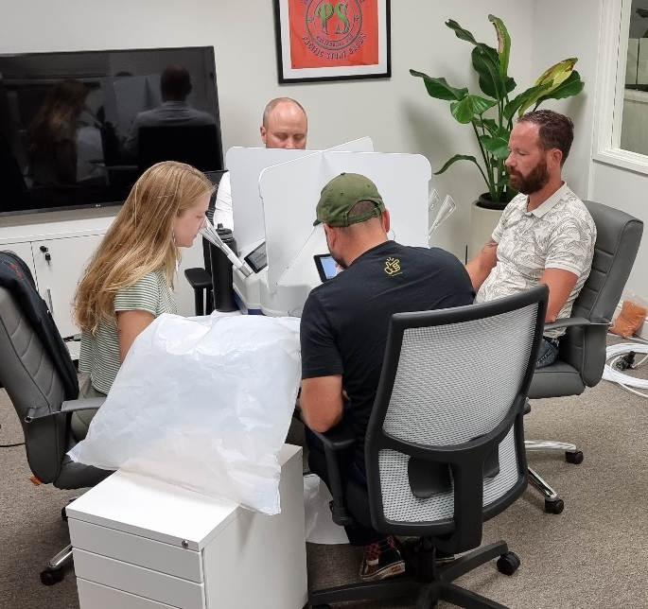 | REQUIREMENTS
 | - Be motivated to perform the task diligently.
 | - Be available for both screening and testing periods.
 | - Odor panelists will be asked to volunteer in 4-hour shifts during the study period. These shifts can take place between 9:00 am and 6:00 pm.

IF INTERESTED, PLEASE SEND YOUR NAME, EMAIL, AND PHONE NUMBER TO:ODORSTUDY@CITYOFMARINA.ORG

